**Project Management Plan**

Agile SDLC Methodology

September 5, 2021, Version 1.0

Team 03_06

horizontal line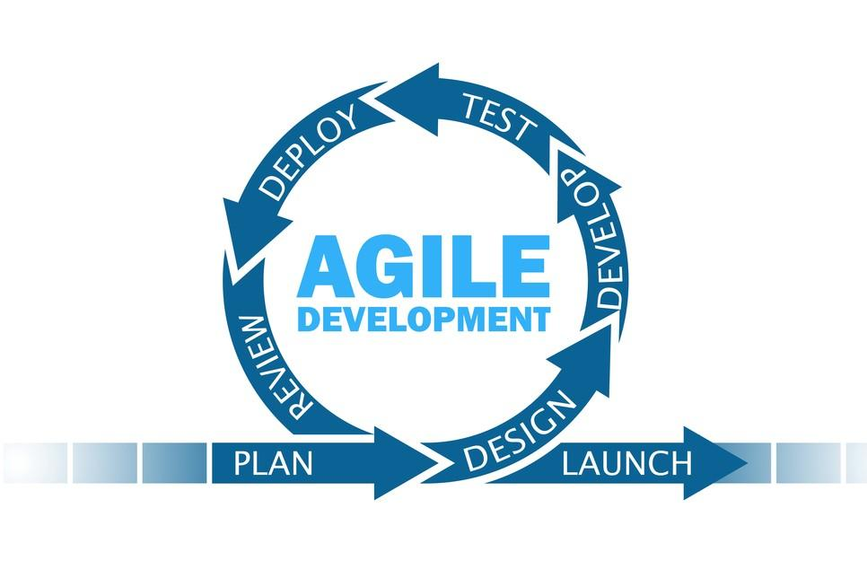horizontal line

**Team member** **Student ID**

Yulai Luo 1292556

Yidi Xiang 1227747

Xuanzhe Meng 1274752

Rucheng Fang 1252034

Jieyun Peng 1174519

# **1 Executive Summary**

Under the situation that Sally and Anne decided to design Travelling Technology Bus to help students study STEM subjects, our team will utilize the Scrum framework of the Agile model to execute a project plan for building a web application that could manage the schedule of the travelling bus.

The purpose of the document is to determine and elaborate the outcome and scope of the project, involved stakeholders, adopted the SDLC model and the corresponding strategies, business value, existing constraint, related technologies and potential risks. And the audience of the document includes project members, stakeholders and the potential supervision department of the government.

The key stakeholder section of the project planning consists of external stakeholders and internal stakeholders. They are core people to promote the project successfully. The scope part describes in detail what needs to be done during the development process and what is not included in the development requirements. Besides, the SDLC section explicitly states the reason why we choose the Agile model instead of the Waterfall model. The advantages of Agile are expressed by exhaustive comparison between two models. In addition, the business value part of the project consists of financial or non-financial benefits which pertain to its strategic objectives, regarding each stakeholder, and the constraints include scope, time, cost, and the existence of Covid-19.

Our team have five Scrum roles, which are Product Owner, Scrum Master, Dev Team Members, Subject Matter Expert, who will work together to guarantee the smooth running of the project. As for the communication plan, we maintain two plans, one in-team communication plan and one communication plan for stakeholders. Furthermore, the specific risk management section contains the details of unforeseen events that are particular to our project, and our risk response strategies. And the generic risk management section contains the problems that most development projects may encounter. We also determine the technologies to use, which is the WordPress framework. The decision of this is made from comparison to Wix and Java-based web applications.

Finally, the document presents the Sprint Plan for the first sprint, with a Sprint Goal, a Sprint Backlog, an initial Sprint Swimlane board and an ideal Burndown Chart and Velocity. It decomposes user stories from Product Backlog into low-level Sprint User Stories. Then the decomposed user stories are associated with tasks for us to implement. And we have created and signed a group contract. It includes four sections, which are group meetings rules, group work rules, group culture rules and conflict solving rules. They are critical to the success of the project and will be obeyed carefully by all team members.

# **2 Table of Contents**

**1 Executive Summary** i

**2 Table of Contents** ii

**3 Introduction** 1

**3.1 Purpose of document** 1

**3.2 Audience of document** 1

**3.3 Evolution of document** 1

**4 Project Information** 2

**4.1 Key Stakeholders** 2

**4.2 Scope - What is in-scope?** 4

**4.3 Scope - What is out-of-scope?** 5

**4.4 Delivery approach / SDLC - Formal or Agile** 6

**4.5 Business Value (Financial & Non-Financial Benefits)** 7

**4.6 Constraints** 9

**5 Project Governance** 10

**5.1 Roles and Responsibilities** 10

**5.2 Communication Plan** 12

**5.3 Risk Management-specific risks** 13

**5.4 Risk Management -generic risks** 15

**5.5 Technology** 16

**6 Project Planning** 19

**6.1 Project planning** 19

**6.2 Group planning** 23

**References** 25

# **3 Introduction**

#### **3.1 Purpose of document**

The purpose of the document is to determine and elaborate the outcome and scope of the project, involved stakeholders, adopted the SDLC model and the corresponding strategies, business value, existing constraint, related technologies and potential risks. It could also be used by the project team to record, promote and review the development of the project. In addition, stakeholders and other relevant personnel could better understand the project through the document.

#### **3.2 Audience of document**

The audience of the document includes project members, stakeholders and the potential supervision department of the government.

#### **3.3 Evolution of document**

|  |  |  |  |
| --- | --- | --- | --- |
| **Version** | **Individual Responsible** | **Date created** | **Comments** |
| 1.0 | **Significant contribution:**  Yulai Luo  4.4, 5.1, 6.1  Yidi Xiang  4.6, 5.2, 5.5  Xuanzhe Meng  4.1, 5.3  Rucheng Fang  4.2, 4.3, 5.4  Jieyun Peng  4.5, 5.3  **Together:**  1, 2, 3, 6.2 | 05/09/2021 | Each team member makes a major and equal contribution to the evolution of the document. The individual responsibilities assigned to each member are discussed carefully and agreed upon by all team members. The person who has an advantage in a specific area will undertake the tasks in the relevant field. In addition, the workload is carefully decided to ensure that each team member makes an almost equal contribution. |

# **4 Project Information**

#### **4.1 Key Stakeholders**

The stakeholder refers to an individual or a group who may affect a direction, activity, or consequence of the project [xuanzhe-1]. The stakeholder may have different types based on the project, it generally consists of users, governance, influence, and providers [xuanzhe-2]. This section describes the role-based Stakeholders for the scheduling system, and it contains basic information of an individual or a group, their role on the project, their effect on the project, suggestions for each stakeholder. The following table illustrated the properties of stakeholders for this system.

|  |  |  |  |
| --- | --- | --- | --- |
| Name | Internal/External | Role | Level of Stakeholder Engagement |
| Sally Lee | Internal | Product Owner | Leading |
| Anna | Internal | Product Owner | Leading |
| Anna’s team | Internal | Project Team | Supportive |
| Business Sponsors | Internal | Sponsors | Supportive |
| Admin User | Internal | End Users | Supportive |
| School | External | End Users | Supportive |
| Staff (Casual or Support Staff) | External | Suppliers | Unaware |
| Teacher | External | Suppliers | Unaware |
| Student | External | Customers | Unaware |
| Cooperator from local government (Donation) | External | Government | Supportive |

**Internal stakeholder**

The Internal stakeholder aims to make this scheduling system available to customers and users. Any problem occurring in internal stakeholders may have serious impacts on project development or maintenance. Thus, each internal stakeholder is indispensable to the project. For the project Travelling Technology Bus, Sally, Anna, and her team are responsible for project development, and they are critical people of this project, which could change the direction and make the decision in project management. In addition, they are competent to negotiate with business sponsors and the government.

Business sponsors are the main budget resource for this project development, they are typically business partners and contractors. This is a non-profit education project designed for students; hence it is essential to guarantee the lack of budget will not happen during the development.

Admin user is an end-user for the scheduling system after project releases. To use this Web Application, it needs the admin user to have basic knowledge of website content maintenance and awareness of network security. Not only just complete daily missions, but admin users are also capable of identifying threats and vulnerabilities. For example, an admin user should have the ability to detect a phishing email by inspecting the email domain. Maybe it is considered to hire a security consultant responsible for the web security domain. We only divide the level of external stakeholder engagement into two types that are leading and supportive because this is a non-profit organization. We assume that there is no conflict of interest among external stakeholders. Moreover, the organization should monitor the participation of stakeholders as this case study [xuanzhe-3] mentioned that poor participation causes negative impacts on the project such as corrupt practices and client dissatisfaction. These risks are possible to happen based on the situation and we should avoid them during the development of process and maintenance.

**External Stakeholders**

External Stakeholders in this project are suppliers, customers, and the government. Although stakeholders do not conduct direct interference in the development process, they cause effects on the long term of the project. Students are customers while staff and teachers are the main suppliers after the scheduling system release. Communication between these two groups is significant as suppliers provide customers with services then the organization can get feedback. Despite teachers is the most suitable choice because of their rich educational experience and better learning abilities, it is hard to hire enough teachers in a short team. The organization can hire volunteers as casual staff after short-term training. However, this strategy might bring some potential problems because of casual staff’s mobility. Schools that are interested in this project could mobilize some teachers to fill the casual staff positions. The Travelling Technology Bus could provide service for school as a reward.

In conclusion, this scheduling system is mainly beneficial to students as each participating student can benefit from the activities which increase their interest and knowledge in STEM. While the stakeholder is a key point to make the project successful, the management of stakeholders is difficult. Because the organization needs to realize that the development of the stakeholder mindset is a significant part of successful project management [xuanzhe-1].

#### **4.2 Scope - What is in-scope?**

|  |  |  |
| --- | --- | --- |
| User Stories | Story Point | Sprint |
| As an admin user, I want to use the default e-mail address and password to access the system so that I can manage the system after login. | 20 | 1 |
| As a school representative, I want to register on the School Registration Web Page so that I can log into the system. | 15 |
| As a school representative, I want to register the expression of interest on the Expression of Interest Web Page so that I can request a bus visit. | 15 |
| As an admin user, I want the system to automatically send an e-mail to me so that I can know that a new expression of interest has come for scheduling. | 15 | 2 |
| As an admin user, I want to view all the expression of interests received on the Expressions of Interest Listing Web Page after logging into the scheduling system so that I can do further operations for rostering a schedule for a school. | 15 |
| As an admin user, I want the system to allow a new web page to display after clicks the hyperlink for any school on the Rostering a Schedule Web Page so that I can roster a schedule for a school. | 10 |
| As an admin user, I want the system to automatically send an e-mail to the corresponding school representative so that they will be reminded to choose a time from the schedule. | 10 |
| As a school representative, I want to choose and confirm the time for the bus visit on the Schedule Web Page after logging in so that the bus can visit on the scheduled time. | 15 | 3 |
| As a school representative, I want to log in and operate on the Cancelling a Scheduled Visit Web Page so that I can cancel a scheduled visit for the Technology Bus. | 15 |
| As an admin user, I want the system to automatically send an e-mail to me after a school representative cancels a scheduled visit so that I can know the information about bus cancellation. | 10 |
| As an admin user, I want all the data entered will be persisted. | 10 |

#### **4.3 Scope - What is out-of-scope?**

1. In requirement 1, there is no need to create a separate user interface for the administrator who will use the default account login page because all the users shall use one interface.

2. There is no need to set up the function of verifying the email address on the user registration interface, even if the school representative enters an unavailable email address.

3. In requirement 5, as the client needs all expressions of interest collected in a tabular form, we do not need to develop other different types of forms to store this kind of information.

4. Although the schedule needs to be arranged by the administrator on the Web, the system does not need to generate a new schedule based on the time selected by the school representative.

5. There is no need to plan the bus route according to the schedule.

#### **4.4 Delivery approach / SDLC - Formal or Agile**

☐ Waterfall ☑ Agile ☐ Incremental

Agile is considered the most suitable Software Development Life Cycle for the case study by all team members and its principle and methodologies will be utilized throughout the whole project. Compared to the Waterfall model, the Agile model performs better in the aspects of system structure, project development process, software testing and product quality.

The Scrum methodology is decided by all team members to be the approved agile framework and will be implemented by us throughout the whole project. Scrum is an Agile framework to help people to address complicated and adaptive difficulties, and productively and creatively deliver outcomes with the highest potential benefit [4].

From the aspect of system structure, Agile is more suitable than Waterfall for the Scheduling System which has multiple complicated and non-sequential deliverables. Agile has its advantages if the project does not always develop sequentially and has complicated deliverables and incremental development, [5]. The scheduling system has multiple subsystems including the administration system, school management system, bus management system and database system. Those subsystems lead to the high complexity and demand diversification of the Scheduling System. On the other hand, the administration system, school management system, bus management system and database system are not strongly correlated and could be developed non-sequentially. These two attributes make the project quite suitable to adopt the Agile model. However, the Waterfall model is often more accommodated to less complicated projects or projects that have exhaustive specifications, means and roles for group members [5]. Due to the high complexity of the Scheduling System, Waterfall is not an appropriate model for this project.

When it comes to the project development process, Agile is more appropriate than Waterfall for the Scheduling System due to its high flexibility. And High flexibility leads to the regular adaptation to frequently varying circumstances. Agile divide the project into short sprints that are both manageable and flexible enough to allow the team to implement changes on short notice. This unique high flexibility is the substantial reason to enable dynamic organizations to be fond of utilizing the Agile model in the project [6]. The Scheduling System has potential needs for changing the requirements due to the lack of details on documents. For example, restriction for the input of the School name field is text. However, there are better choices like an options menu for students to select a certain number of schools to avoid mistakes. This kind of change of requirements is possible to appear during the project development process. At that time, the Agile model could adapt to the changing circumstances smoothly and flexibly. But Waterfall does not allow for ambiguity and is markedly hard to adapt to variations [7]. During the development of the Scheduling System, the changes are hard to deliver and may consume huge resources.

As for the software testing, Agile perform better than Waterfall due to its real-time testing after every sprint. Agile delivers testing concurrently with software development but Waterfall requires the testing to occur after the “Build” stage [8]. The Scheduling System has multiple complicated and non-sequential deliverables like the administration system, school management system, bus management system and database system, which could be implemented in separate sprints. After every sprint, instant testing is necessary as the delayed testing may cause big problems which need large costs to solve. Agile carries out instant testing after every sprint of the development of the subsystems, resulting in a relatively small consumption to solve the problems. However, Waterfall put the testing phase after the complete construction of the project. At that time, the problems among separate components of the project are hard to distinguish and solve. Even the issues are settled, it could consume a large number of resources.

In terms of product quality, Agile could produce a higher-quality Scheduling System than Waterfall could. Agile could offer outcomes with higher quality and user-friendly attributes [9]. Clients could present feedback to the project team after every sprint so that the products produced using this approach usually end up being quite user-friendly [9]. During the development of the system, there are several sprints to implement the subsystems of the Scheduling System such as administration system, school management system, bus management system and database system. If Agile is used, the clients could throw out a suggestion to help improve the product quality after each sprint. At that time, any suggestions from the stakeholders could be utilized and executed by the project team. However, the Waterfall does not support real-time feedback from the clients. It decreases the chance of comprehensively improving the product. In addition, Agile also increases clients satisfaction by frequent communication, whereas Waterfall may lead to the dissatisfaction of clients because of its lack of communication and falling short of the new requirements.

In conclusion, Agile is more suitable than Waterfall for the case study as it performs better in the aspects of system structure, project development process, software testing and product quality. Although Agile has many advantages as above, its drawbacks like potentially more expensive consumption and longer deadline might hurt the development of the project [10]. We will pay close attention to the issues caused by Agile’s drawbacks and minimize their impact on the project.

#### **4.5 Business Value (Financial & Non-Financial Benefits)**

**Non-Financial Benefits**

Government & 'Not for Profit' organization:

For the government and the 'Not for Profit' organization set up by Sally and Anna, the online system can be propaganda on STEM education across all age groups and areas for public interests.

Sally:

For Sally and many other parents, the online project provides a good channel for their children to learn STEM knowledge under COVID-19 restrictions, allowing the school to uniformly manage and organize the visits, which is a more standardized, systematic and safe approach.

Anna's team:

The project is conducive to the growth and construction of Anna's team and company. The project itself is also external propaganda for the company.

School:

Based on the remote communication function available for the moderator and schools, the online system has greatly improved the efficiency [11] of STEM education for regional schools and also brought flexibility[11] for schools to arrange the learning activities.

**Financial Benefits**

Government:

Through improving and innovating the education idea about STEM, this project also promotes relevant consumption and promotes employment through recruiting casual STEM staff, which generates certain tax revenue.

School:

For most regional schools as end-users in this project, the service provided is a more low-cost alternative to STEM incursions or excursions [1], for similar educational goals.

Sponsor:

The project is also a commercial promotion for sponsors who provide the device and technique, also the booking services of "Specialized Activities" and the teacher skill augmentation sessions which are available online in the future would bring them extra income.

#### **4.6 Constraints**

**Triple Constraints**: Scope, Time, and Cost.

The classical triple constraints of scope, time, and cost apply to this project [12]. As the project phase1 will be undertaken by student teams, the cost of human resources can be assumed minimized, as the students’ work is their required course contents. Additionally, the students that work for this project is enrolled in the SWEN90016 class, which limited their time to no more than one semester (3 months). As the agile approach is chosen, according to Cencula [13], the triple constraint for formal approaches are inverted. With given time and cost, the scope here become the relative factor that depends on the other two [13]. Thus, to make sure the required quality of the software is fully achieved, time, cost and scope should be rationally managed to achieve a perfect balance by the team. Since the human resources cost is minimized in this project, the cost constraint gets eased, which makes room for time and scope.

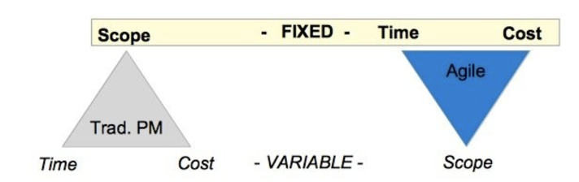

***Figure 1*** *Time, Cost, Scope*

**The existence of Covid-19.**

Another constraint that must be considered during the development of software projects is the existence of Covid-19. As we know, the Covid-19 situation has limited the physical space that SWEN90016 students can travel. For most students of SWEN90016, most certainly the whole project would be undertaken online, including all project management and software development activities. This could apparently affect the team members efficiency and effectiveness in co-operation, which makes it a constraint worth taking notes of.

# **5 Project Governance**

#### **5.1 Roles and Responsibilities**

**Scrum Master:** Yulai Luo.

In this project, the Scrum Masteris responsible for leading the Scrum process, eliminating problems or barriers throughout the project, teaching the group to follow Scrum rules, values and methods and encouraging the beneficial collaboration between the stakeholders and the Scrum team [14].

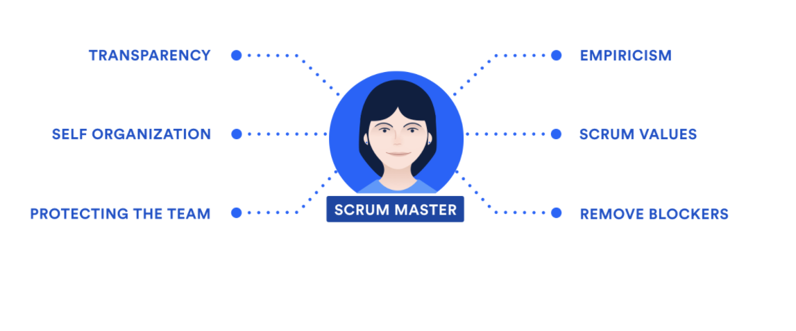

***Figure 2*** *Scrum Master*

**Product Owner:** Yidi Xiang.

In this project, the Product Owneris responsible for defining the business vision and specifications and strategies for the product, understanding and interpreting client requirements for the development team, deciding the scheduled release date for product characteristics and controlling the product backlog [15].

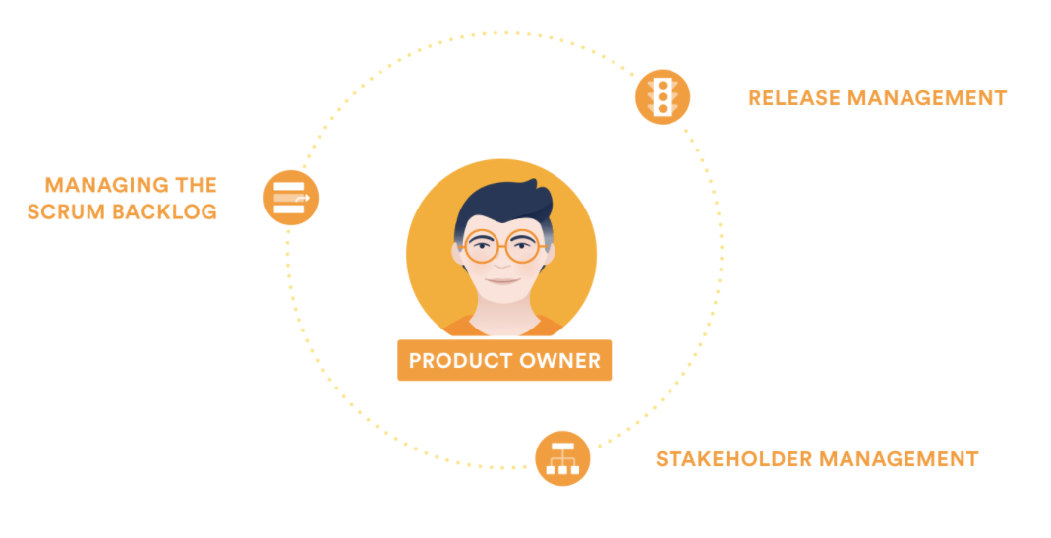

***Figure 3*** *Product Owner*

**Development Team Members:** Xuanzhe Meng and Rucheng Fang.

In this project, the Dev Team Membersare responsible for delivering the requirements of the products throughout the project, arranging their workload and the way to finishing it, combining individuals with various skills to achieve targets and working in the same place to promote osmotic communication [17].

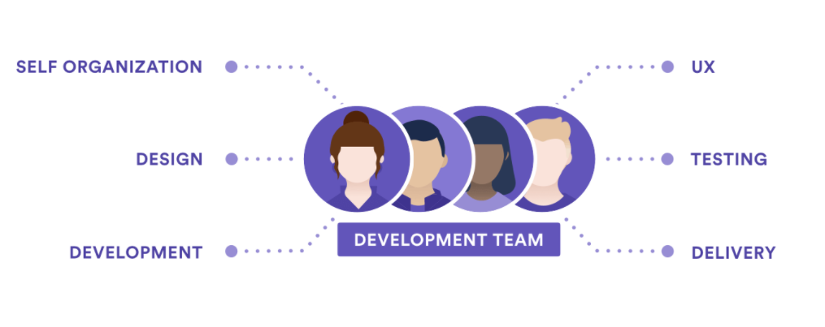

***Figure 4*** *Development Team*

**Subject Matter Expert:** Jieyun Peng.

In this project, the Subject Matter Expertis responsible for professionally teaching the Scrum team how stuff works and bringing related domain knowledge to the team to help them make more knowledgeable choices and produce more solid strategies to accomplish targets [18].

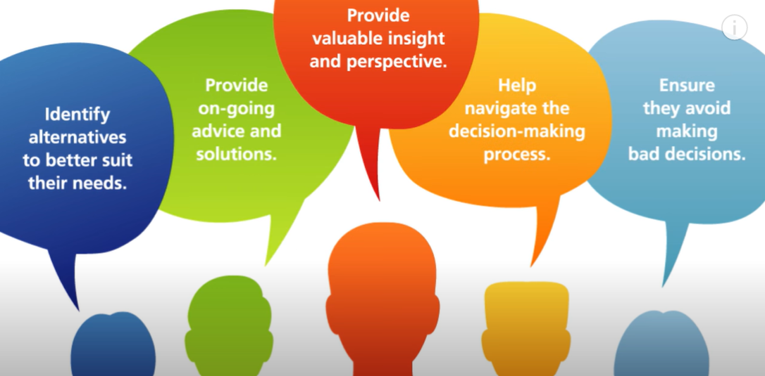

***Figure 5*** *Subject Matter Expert*

#### **5.2 Communication Plan**

The communication plan is divided into two parts: in-team communication, and communication with stakeholders.

For in-team communications, we picked Zoom as the go-to formal communication method. As a virtual team, Zoom provides us with the ability to hold scrum meetings of all kinds in a pseudo and face-to-face way. For casual communications, we picked WeChat, as some of our team members are in China, which makes it hard to use communication tools like Messenger (needs VPN). For formal notice of work that needs records, we would use emails. We also picked WhatsApp as our contingency plan for in-team communications. Besides, the frequency of in-team meetings happens every 3 days.

As a virtual team, constrained by the Covid-19 situation, real face-to-face communication is hard to achieve. For each occasion that requires a face-to-face meeting, we replace it with a Zoom meeting. Using Zoom inside the dev team is free of charge, and will incur fees when communicating with stakeholders. If there are issues with Zoom, we have a contingency plan of using Tencent Meeting, which is free of charge.

For communications to stakeholders, a communication matrix is attached below.

|  |  |  |  |  |  |
| --- | --- | --- | --- | --- | --- |
| **Stakeholder** | **Communication Objective** | **Format** | **Frequency** | **Owner** | **Importance** |
| Sally Lee | Provide updates on the project on each sprint | Email/ Zoom | Weekly | Product Owner | High |
| Anna’s Team | Ask for resources needed whenever needed help | Email/ Zoom | Bi-monthly | Scrum Master | Medium |
| Government Donors/ Business Sponsors | Provide and present the completed project to gain funding, and keep providing updates once they sponsored | Email/ Zoom | Monthly | Product Owner | High |
| School representatives and teachers | Gain potential users’ (schools) feedback on the project | Email/ Zoom | Once during the project planning phase | Product Owner | Medium |

#### **5.3 Risk Management-specific risks**

(Note: the table format has been adjusted by us for the elegance of the report. The content of the table remains unchanged.)

**Risk Impact Analysis Table:**

|  |  |  |  |  |  |
| --- | --- | --- | --- | --- | --- |
| **Risk ID** | **Risk Type (Business/Project/Product)** | **Description** | **Probability (0-100%)** | **Impact (1-10)** | **Justification** |
| R1 | Project | The first risk we found is that the project contains an issue of information security. For requirement 10, we can see that all of the data is stored in a single database but there is not any requirement for the security domain. One of the vulnerabilities is the password for the admin user. In requirement 2, there is no restriction for password selection. If Admin user password composition is weak, then the attacker can just perform the brute force cracking to try all possible combinations of characters to match the correct one. An eight-character password consisting of all lower-case letters has 26^8 combinations and this is a huge number for a human’s brain. However, a common password cracking tool only needs a few mins to enumerate all the probabilities and find the correct one [18]. If an admin user enhances the password complexity such as involved number, symbol, the number of combinations increases exponentially. This makes the amount of time to crack passwords increased to a few years. | 10% | 7 | Information security is an important issue regardless of what kind of information is stored. The project must ensure confidentiality, integrity, and availability [1]. Otherwise, schools might reject participation in this school because we cannot guarantee their information security. The website can be more secure by adding a few steps during the development. |
| R2 | Product | The second risk we found is the performance may not reach full requirements. The core reason for this risk is the work pattern. Our delivery approach is agile, but it is hard to follow all the procedures in agile based on our situation. For example, team members now study in their cities because some ceremonies in agile may not be implemented such as daily stand up. In addition, this situation also reduces the communication between the members. The only way to communicate is by email, phone and online sessions. Overall, if scrum master finds errors or changes the direction, then others might not realize the changes or errors immediately during the development process. These factors may affect the quality requirement of the project, thereby affecting the final performance. | 50% | 6 | During the product development process cycle, some members of the development team may choose to leave the team because they feel that the work arrangement is unfair and they did not receive a salary that matched the effort they put in. |
| R3 | Product | Considering a large number of scenes of email sending in this multi-user system, the performance risk of the system is worth being concerned about. Some unstable factors will affect the sending of emails, such as network jitter, communication abnormalities, and even concurrent pressure, which should be considered in the design phase. | 20% | 6 | The communication reliability should be ensured for both moderator and schools, in all scenes including expression of interest, the scheduling, or cancellation of the bus visit. The risk of loss of messages will lead to an interruption of business processes. |
| R4 | Project | Due to the need for start-up funds, the main business should be realized with the help of business sponsors, and thus cannot be carried out simultaneously with the web application, which is 'Proof of Concept' and those factors in the production environment are not taken into account. So, there is a process risk due to quality assurance problems in the early stage, and defects may arise when the project comes into operation in the later stage. | 60% | 4 | The output products of a process will not be of higher quality than the input products[16]. If the products have defects, they will not disappear later but will be amplified. So without initial control on quality, afterwards maintenance is required to amend arisen defects. This might result in enormous work of technical support. |
| R5 | Project | A single point of failure may affect the entire project and even lead to rework due to the interdependence of each requirement. This is because those requirements are mostly designed to be sequential, where some required text and data fields are auto-populated from the previous requirement.  For example, the schedule functionality appears in requirement 6 for the first time. Suppose we make a mistake for the schedule feature and don’t realize it until we finish the entire project. Then, we need to fix errors from requirement 6 to requirement 9 as they contain wrong schedule functionality. | 60% | 6 | We choose this risk because the requirements in this project are sequential. Even a small error that occurs in the initial requirement may affect the future requirements because of high dependency. If we ignore the errors in the previous requirements, then the debug process will be expensive in the end and the release time also might be delayed. |

**Risk Register:**

|  |  |  |  |  |  |
| --- | --- | --- | --- | --- | --- |
| Risk ID | Trigger | Owner | Response | Response Strategy Type | Resources Required |
| R1 | Once an attacker tries to hack the system. | Project Team | We can conduct some strategies to mitigate this risk.  The website does not accept the simple password composition and it should contain special characters, digits and characters. In addition, we can implement multi-factor authentication. When an admin user account requests to log in, a verification code is sent to the user’s phone, the user needs to enter the code to log into the admin account. | Mitigate | None |
| R2 | Lack of communication as a team completes this process by remote working. | Project Team | We can make a good communication plan before the development to mitigate this risk. For example, to perform virtual daily stand up and sprint reviews to conclude the daily development. | Mitigate | More communication time |
| R3 | Messages are lost after being sent. | Project Team | First, a stable protocol of email sending should be confirmed beforehand in the design phase. The appropriate design can be a distributed system for message transfer with re-transmission mechanisms. Second, performance testing is also needed before delivering the project. The above strategies would result in a residual risk with lower probability and impact[17]. | Mitigate | Performance test environment |
| R4 | Customer complaints caused by system problems. | Project Team | The end-user trial process can be introduced, with periodical communication with users about work results. Leaders should carefully organize the detection and review of output products and conduct strict testing such as effective boundary testing on each iterative function. When the software product comes into operation, after-sale service or technical support should be available. | Mitigate | Product and technical support  personnel  test cases and equipment |
| R5 | A single error in one of the requirements causes a serious impact on the project. | Project Team | The development progress should be managed through good planning and monitoring. There should be enough communication and feedback inside the project team to well confirm the requirement details and develop the schedule, so as to respond to changes and errors.  We could also decouple the project to reduce its inner dependencies. One way is to apply the developed model of separation of front-end and back-end, where the static pages without data can be prepared in advance. The developing process then ends with a joint debugging test to verify the design meets the system requirements. | Mitigate | None |

#### **5.4 Risk Management -generic risks**

(Note: the table format has been adjusted by us for the elegance of the report. The content of the table remains unchanged.)

**Risk Impact Analysis Table:**

|  |  |  |  |  |  |
| --- | --- | --- | --- | --- | --- |
| **Risk ID** | **Risk Type (Business/Project/Product)** | **Description** | **Probability (0-100%)** | **Impact (1-10)** | **Justification** |
| R1 | Business | Few users use this product | 20% | 3 | After completing the production of the web, few people may register for this system. This situation may be since the organizer of the event did not carry out reasonable publicity. As a result, most schools that were originally willing to participate in the event did not know that there was such a channel. This may cause no one to care about this product. |
| R2 | Project | Someone quit during the development process | 40% | 6 | During the product development process cycle, some members of the development team may choose to leave the team because they feel that the work arrangement is unfair and they did not receive a salary that matched the effort they put in. |
| R3 | Product | The developer may have insufficient professional competence for a certain skill | 10% | 9 | There may be certain jobs that require special skills during development, but there are no members with this ability in the entire development team. This may cause the progress of the product to stagnate. |
| R4 | Project | The time may not be enough during the development process | 20% | 6 | Halfway through web development, the team found that the remaining development process may not be completed due to a limited time. |
| R5 | Project | There may be security issues in the process of using the web | 20% | 9 | Some criminals may obtain a large amount of school information by attacking this web and may also use this system to learn the whereabouts of the travelling bus and destroy it when the activity is carried out. |

**Risk Register:**

|  |  |  |  |  |  |
| --- | --- | --- | --- | --- | --- |
| **Risk ID** | **Trigger** | **Owner** | **Response** | **Response Strategy Type** | **Resources Required** |
| R1 | There were fewer than 5 new users a week after the web went live. | Project Team | The organizer of the event can increase the intensity of communication and publicity and can send people with professional knowledge to various schools to carry out lectures on this event. | Avoid | Time and human resources |
| R2 | There was a conflict between the members of the development team and the Scrum master because he was asked to take on too much work alone. | Project Team | When assigning work, the team needs to be more careful to judge whether each work is evenly distributed to each developer. | Avoid | Time |
| R3 | In the process of developing the web, an algorithm is needed to support the normal operation of the system, but no team member has the ability to solve this algorithm problem, which causes the web to fail to display normally. | Project Team | Team members can get help from other people with relevant experience outside the team by paying a certain amount and use this knowledge to solve the problem. | Avoid | Working space |
| R4 | The team found that the remaining time was not enough to finish the whole product. | Project Team | The team can give feedback to the event organizer and get an extension. | Avoid | Time |
| R5 | On the way to school, vehicles with the same characteristics are often found trailing behind. And school representatives often receive harassing calls. | Project Team | Pay attention to the protection of data while developing the web. The team can add a firewall to the database to block the attacks of criminals. | Mitigate | Time |

#### **5.5 Technology**

The final choice of framework to utilize is WordPress. A complete rundown of our decision process is shown below.

**Analysis of Requirements:**

The main purpose of the system is to schedule the time for visits to different schools that want the services of the travelling bus. The interaction needed in this system is mainly between the character of the admin user and school representatives. The whole process initiates with a school representative with interests and ends with a consensus from both sides on either a determined schedule or a cancellation on the EOI. From this information, the functionalities of this system are not nearly as complicated as an enterprise-level web application. However, it’s not a static exhibition website, either.

To gain a deeper understanding, an analysis of the requirements shall be performed. To decide or restrict a circle of choices of software developing framework to use, the functionalities that map the requirements should be extracted. For requirements 1 & 2, it’s clear that a login function is needed, along with the ability to distinguish between different types of users (Admin User and School Reps here). Requirements 3, 5, 6, 8 all map to the functionality of filling and showing forms, from which we know that we need a multi-functional interactive form component. From requirements 4, 7, 10, functionality of sending emails with automatically fetched contents is required from both types of users. Requirement 9 tells that a form responsible for showing part of fetched contents is needed, along with the ability to delete records from the database.

The functionalities of a login system, interactive forms, automated generated emails, and persistent database storage became the go-to criteria when we search for developing technology. We limited our choices to three options: WordPress, Wix, or developing a Java-based web application.

**Comparison & Decision:**

Our final range to choose from includes WordPress, Wix, or developing a Java-based web application. WordPress [19] is an open-sourced, PHP and MySQL-based Content Management System. Wix [20] is a commercial SaaS (Software as a Service) platform that provides the ability to build websites swiftly. As for a Java-based web application, it’s the whole package of frontend (including HTML, CSS, JavaScript), backend (Java), and data persistence (MySQL).

The easiest to use from the three choices is undisputedly Wix [20]. Similar SaaS options like Squarespace [22] are also researched, but Wix wins over Squarespace for its freedom to modify page layouts. Wix provides beautifully designed components to exhibit on the webpage [26]. Moreover, as a website builder, the learning curve of Wix is much less steep comparing to WordPress or Java-based [26]. However, the functionality provided by Wix is, thereby, limited. The choice of functionalities comes from its app market, but there aren’t many to choose from [26]. Though it can meet the current functionality requirements, it’s hard to scale up to some of the Phase2 requirements.

For a Java-based application, the scalability and functionality are close to limitless. The server can be hosted by ourselves, the logic can be customized in any way we want. Through proper designing and designing, it can scale up to meet Phase2 requirements without a doubt. However, it might not be the best option for this project. As discussed in 4.6 Constraints, the cost allocated to this project is very limited, as well as the time. Additionally, the development team might not be proficient with Java. If that’s the case, the development process could be very, as the learning curve of Java itself is already considerably steep.

Word-press is an open-sourced CMS that charges none by itself. It provides an enormous amount of themes and plugins, that extends its functionality to fit most of the websites’ needs [25]. This can be simply proved by the percentage of current-running websites that use WordPress [23]. With some basic level of PHP knowledge, it’s relatively easy to build a website based on it [21]. WordPress can cover our requirements in both Phase1 and Phase2, with much fewer efforts on the development process comparing to Java-based. Moreover, unlike Wix, we can choose to host the server of WordPress on our own. In the future, ads are possible to bring profits to Sally, which can later be used on scaling up this non-profit project to benefit more people. The downsides to WordPress lie in its upside as well. Because of its openness, the themes and plugins provided by WordPress are mixed and diversified. Some of the themes and plugins do charge different amounts [24]. Hence, when using WordPress, the development team needs to carefully choose from the ocean of themes and plugins.

|  |  |  |  |
| --- | --- | --- | --- |
|  | **Wix** | **WordPress** | **Java-based** |
| **Type** | Close-sourced SaaS | Open-source CMS | Construct from scratch |
| **Design & Implement Webpage** | Mostly drag & drop, visually, intuitively | Start with existing template and modify; Not visually and intuitively, pertains to some level of abstraction | Need solid knowledge of HTML, CSS, and Javascript; Not at all visually and intuitively |
| **Scalability** | Low | Moderate | High |
| **Self-host servers** | No | Yes | Yes (Compulsory) |
| **Cost** | Charged Monthly | Free (may pay for charged themes or plugins) | Fees for a development tool, website hosting, domain name charge, etc. |
| **Functionality** | Low | Moderate | High |
| **Support Ads** | No | Yes | Yes |

# **6 Project Planning**

#### **6.1 Project planning**

By utilizing Scrum methodology, we divide our project into three sprints, which means one sprint lasts for a week due to the time limit of three weeks. The following content is the planning related to the first sprint in week 9 for the project.

**6.1.1 Sprint Goal**

To implement the basic functions of the product so that the client could raise instant suggestions and requirements after the first sprint and the development team could design and implement advanced features based on the available and fundamental system.

**6.1.2 Sprint Backlog:**

Three chosen Feature-level User Stories from the Product Backlog and the corresponding Decomposed User Stories:

|  |  |  |
| --- | --- | --- |
| Feature User Stories | Decomposed User Stories | Tasks |
| 1. As an admin user, I want to use the default e-mail address and password to access the system so that I can manage the system after login.  (20 story points) | 1.1 As an admin user, I want to view and operate the login interface so that I can enter the default e-mail address and password.  (10 story points) | 1.1.1 Research and select the proper frontend framework such as React or Vue (2 hours)  1.1.2 Design the login page (3 hours)  1.1.3 Create the prototype of the website login page (3 hours)  1.1.4 Communicate with clients to get their feedback on the prototype (1 hour)  1.1.5 Establish the login page using HTML, CSS, Javascript and other techniques (3 hours) |
|  | 1.2 As an admin user, I want the system to allow me to log in if the entered e-mail address and password are correct so that I can enter and manage the system.  (10 story points) | 1.2.1 Research and select the proper backend framework such as Django or Node.js (2 hours)  1.2.2 Establish the backend using the selected framework and the related programming languages (3 hours)  1.2.3 Implement the function to check whether the entered e-mail address and password match (1 hour)  1.2.4 Implement the function to allow the user to log in successfully if the entered e-mail address and password match (3 hours)  1.2.5 Implement the function to alert that the user if he has logged in successfully (1 hour)  1.2.6 Implement the function to alert that the user if he has failed to login (1 hour) |
| 2. As a school representative, I want to register on the School Registration Web Page so that I can log into the system.  (15 story points) | 2.1 As a school representative, I want to view and operate the register interface so that I can use my information to register an account.  (5 story points) | 2.1.1 Design the register page (3 hours)  2.1.2 Create the prototype of the website register page (3 hours)  2.1.3 Communicate with clients to get their feedback on the prototype (1 hour)  2.1.4 Establish layout of the register page using HTML, CSS, Javascript and other techniques (3 hours)  2.1.5 Add the following User Interface Element to the register page: School Name, School Contact Name, School Contact Number, e-mail address and Password (3 hours)  2.1.6 Add constraint to the input to the User Interface Element: School Name, School Contact Name, School Contact Number e-mail address should be text, the password should be masked characters (3 hours) |
|  | 2.2 As a school representative, I want to register an account so that I can use the account to log in.  (5 story points) | 2.2.1 Implement the function to enable the backend to create a user account on the website when a user successfully registers (2 hours)  2.2.2 Implement the function to alert the user if he or she has successfully registered (1 hour)  2.2.3 Implement the function to alert that the user if he or she has failed to register (1 hour)  2.2.4 Implement the function to store the details of the registered user including School Name, School Contact Name, School Contact Number, e-mail address and Password (3 hours) |
|  | 2.3 As a school representative, I want to log into the system by using the registered account so that I can register the expression of interest.  (5 story points) | 2.3.1 Implement the function to enable the system to check whether the email address and password match (1 hour)  2.3.2 Implement the function to alert the user if he or she has logged in successfully (1 hour)  2.3.3 Implement the function to alert the user if he or she has failed to login (1 hour)  2.3.4 Implement the function to direct the user to the new page if he or she has logged in successfully (1 hour) |
| 3. As an admin user, I want all the data entered will be persisted in database storage so that I could view and edit all stored information.  (15 story points) | 3.1 As an admin user, I want to view and operate the database interface so that I can view and operate the data in it.  (10 story points) | 3.1.1 Research and select the proper database such as MySQL or MongoDB (3 hours)  3.1.2 Establish the selected database in the backend of the website (3 hours)  3.1.3 Create the role of admin user in the backend (2 hours)  3.1.4 Store the default e-mail address and password in the details of the admin user (1 hour)  3.1.5 Create the management page for the admin user (3 hours)  3.1.6 Implement the function to direct the admin user to the management page if he or she successfully (1 hour) |
|  | 3.2 As an admin user, I want all the information entered into the system will be stored in the database so that I can view and operate the data.  (5 story points) | 3.2.1 Implement the function to automatically store the information of all the registered users into the database (4 hours)  3.2.2 Implement function to enable the store data to be persistent in the database instead of being lost after update (4 hours) |

**6.1.3 Initial Sprint Swimlane board**

Initial Sprint Swimlane Board implemented by Trello Tool:

<https://trello.com/invite/b/EQStDM5o/d165dfcc4b569fd8daad088a51e2040b/scrum>

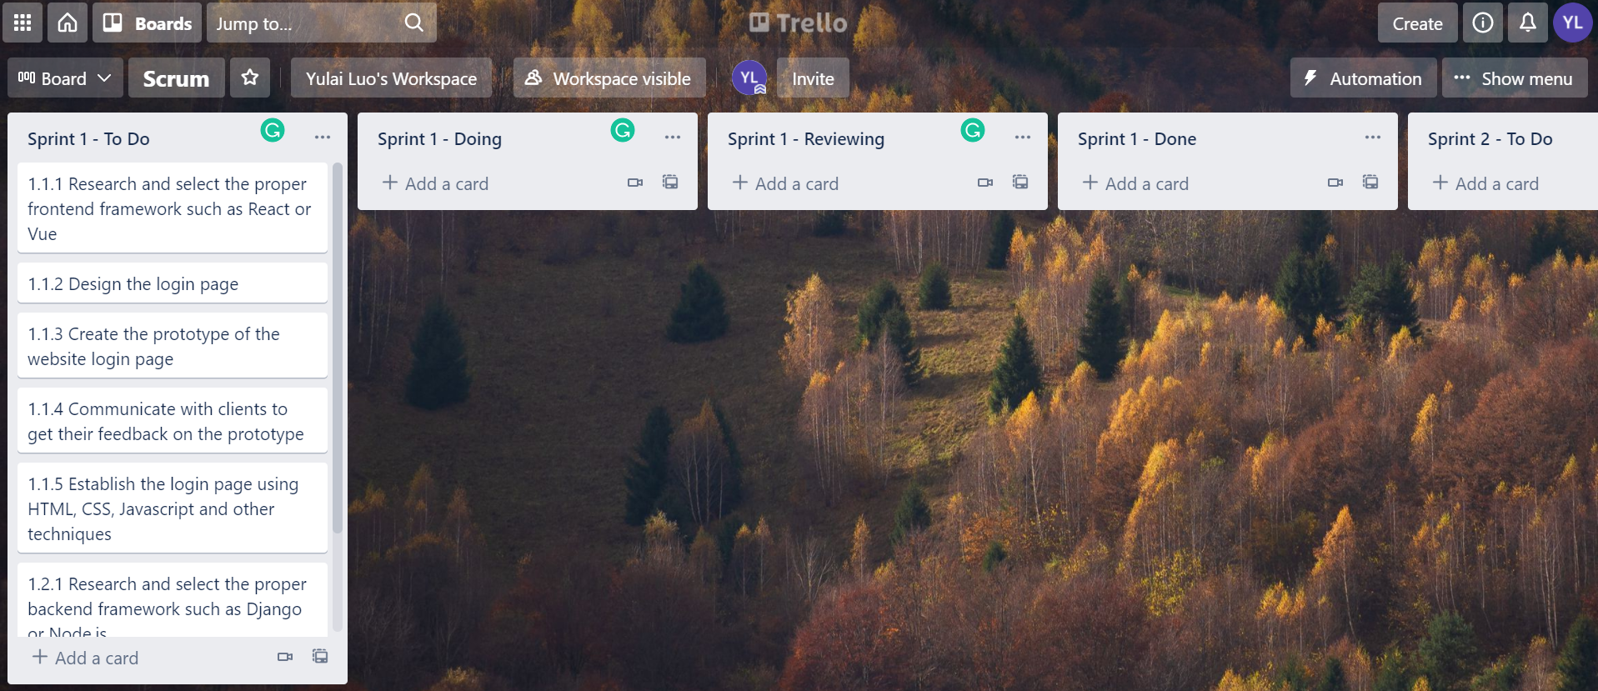

***Figure 6*** *Initial Sprint Swimlane board*

**6.1.4 Ideal Burndown Chart**

Ideal Velocity: 50 Story points done for each Sprint whose period is 1 week.

Therefore, we will ideally finish the 50 story points during the first sprint, whose period is 1 week.

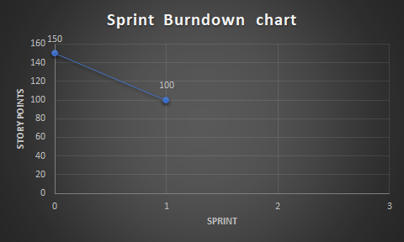

***Figure 7*** *Burndown Chart*

#### **6.2 Group planning**

Below is the group contract created and signed by all group members. It includes four sections, which are group meetings rules, group work rules, group culture rules and conflict solving rules. These rules are critical to the success of the project and will be obeyed carefully by all team members.

1. Group meetings rules

As a collaborative team, we will:

1. Hold a meeting every three days throughout the project

2. Participate in every meeting and make individual contributions, if someone does not participate, he/she should present an acceptable reason to other group members

3. Prepare individual presentations and questions before the meeting

4. Communicate effectively and efficiently with other group members during the meeting

5. Discuss and assign work and responsibilities to each group member during the meeting

6. Take clear and useful notes during the meeting

7. Summarize the important points and share them with other team members after the meeting

1. Group work rules

As a collaborative team, we will:

1. Finish the high-quality individual work based on the discussion during the meeting

2. Finish the individual work on time and put it in the shared google drive

3. Revise the individual work based on the discussion and suggestions during the meeting

4. Help other members with their work if they are calling for help

1. Group culture rules:

As a collaborative team, we will:

1. Fully respect other group members’ opinions

2. Use polite language throughout the project

3. Do not strongly criticize other members’ work if it does not meet the requirements

4. Gently raise suggestions about other members’ work

5. Care about other members’ mental health and physical health

1. Conflict solving rules:

When the conflict happens among group members, we will

1. Hold an extra meeting to solve the conflict

2. Objectively evaluate conflicting opinions

3. Vote to decide the result of the conflict

4. Calm down quickly even there is a big conflict

**Date:** 2021/09/05

**Signatures:**

|  |  |
| --- | --- |
| Yulai Luo |  |
| Yidi Xiang |  |
| Xuanzhe Meng |  |
| Rucheng Fang |  |
| Jieyun Peng |  |

# **References**

[1] Worsley, L. M., *Stakeholder-led project*

*management : changing the way we manage projects*. First edition. Business Expert Press (Portfolio and project management collection), 2017. [Online]. Available:

https://search.ebscohost.com/login.aspx?direct=true&AuthType=sso&db=cat00006a&AN=melb.b6580366&site=eds-live&scope=site

[2] Rogers, M. *et al.*, ‘Stakeholder engagement in an online community education project via diverse media engagements’, *Issues in Educational Research*, 31(2), pp. 626–643. 2021. [Online]. Available: https://search.ebscohost.com/login.aspx?direct=true&AuthType=sso&db=ehh&AN=151341629&site=eds-live&scope=site

[3] Tengan, C & Aigbavboa, C., ‘Level of Stakeholder Engagement and Participation in Monitoring and Evaluation of Construction Projects in Ghana’, *Procedia engineering*, p. 630. 2021. [Online]. Available:<https://search.ebscohost.com/login.aspx?direct=true&AuthType=sso&db=edsbl&AN=vdc.100062138958.0x000001&site=eds-live&scope=site>[>.<https://search.ebscohost.com/login.aspx?direct=true&AuthType=sso&db=edselp&AN=S1877705817331788&site=eds-live&scope=site](https://search.ebscohost.com/login.aspx?direct=true&AuthType=sso&db=edsbl&AN=vdc.100062138958.0x000001&site=eds-live&scope=site%3e.%3chttps://search.ebscohost.com/login.aspx?direct=true&AuthType=sso&db=edselp&AN=S1877705817331788&site=eds-live&scope=site).

[4] "What is Scrum?", *Scrum.org*, 2021. [Online]. Available: <https://www.scrum.org/resources/what-is-scrum>.

[5] "Agile vs Waterfall – What’s the Difference?", *Aipm.com.au*, 2021. [Online]. Available: <https://www.aipm.com.au/blog/agile-vs-waterfall-whats-the-difference>.

[6] "9 Key Benefits of Using the Agile Methodology", *Kissflow*, 2021. [Online]. Available: <https://kissflow.com/project/agile/benefits-of-agile/>.

[7] J. Santos, "Agile vs. Waterfall | Software Development Methodologies", *Project-Management.com*, 2021. [Online]. Available: <https://project-management.com/agile-vs-waterfall/>.

[8] T. Hamilton, "Agile Vs Waterfall: Know the Difference Between Methodologies", *Guru99*, 2021. [Online]. Available: <https://www.guru99.com/waterfall-vs-agile.html>.

[9] P. KUKHNAVETS, "Agile vs Waterfall: Difference Between Two Powerful Methodologies", *Hygger.io Guides*, 2021. [Online]. Available: <https://hygger.io/guides/agile/agile-vs-waterfall/>.

[10] B. Nash, "Agile vs Waterfall: Learn the Differences in 5 Minutes", *Trustradius*, 2021. [Online]. Available: <https://www.trustradius.com/buyer-blog/difference-between-agile-vs-waterfall>.

[11] Gustafsson, P., et al. "Identifying IT impacts on organizational structure and business value." (2009).

[12] R. Shankarmani, R. Pawar, S. S. Mantha and V. Babu, "Agile Methodology Adoption: Benefits and Constraints", International Journal of Computer Applications, vol. 58, no. 15, pp. 31-37, 2012. Available: 10.5120/9361-3698.

[13] P. Cencula, "Agile inverts the Triple Constraints of Project Management", Linkedin.com, 2021. [Online]. Available: <https://www.linkedin.cm/pulse/agile-inverts-triple-constraints-project-management-paul-cencula/>

[14] A. Albertin, "Agile Scrum Roles - 3 Roles that Make or Break Scrum - Agile Scrum", *Agile Scrum*, 2021. [Online]. Available: <https://www.exin.com/agile-scrum/agile-scrum-roles-make-or-break-scrum/>.

[15] R. Schuurman, "The Subject Matter Expert (A Misunderstood Product Owner Stance)", *Medium*, 2021. [Online]. Available: <https://medium.com/the-value-maximizers/the-subject-matter-expert-a-misunderstood-product-owner-stance-73e420851365>.

[16] Kimhan, S. C., & King, D. M. . (1984). The Effects of Software Quality Control and Baseline Management on the Acquisition of Computer Programs.

[17] Marion Zalk (2021). Risk Management. SWEN90016.

[18] Andress J, Winterfeld S, Katsaropoulos C, Limbert M. *The basics of information security : understanding the fundamentals of InfoSec in theory and practice*. Second edition. Syngress; 2014. (The Basics).[Online] Available: https://search.ebscohost.com/login.aspx?direct=true&AuthType=sso&db=cat00006a&AN=melb.b7598899&site=eds-live&scope=site

[19] "WordPress.com: Create a Free Website or Blog", *WordPress.com*, 2021. [Online]. Available: https://wordpress.com/. [Accessed: 09- Sep- 2021].

[20] Wix.com, 2021. [Online]. Available: https://www.wix.com/. [Accessed: 14- Sep- 2021].

[21] K. Baker, "How to Use WordPress: Ultimate Guide to Building a WordPress Website", *Blog.hubspot.com*, 2021. [Online]. Available: <https://blog.hubspot.com/marketing/wordpress-website>.

[22] "Build a Website – Website Builder – Squarespace", *Squarespace*, 2021. [Online]. Available: <https://www.squarespace.com/>.

[23] H. Lee, "Web Design Methodology for Wordpress Site based on WordPress Theme Customization", *The Journal of the Korea Contents Association*, vol. 16, no. 2, pp. 277-286, 2016. Available: 10.5392/jkca.2016.16.02.277.

[24] N. Sethi, N. Bhateja, S. Kaushal and J. Singh, "LAUNCHING WORDPRESS- BLOGS AND DOMAINS", *International Journal of Innovative Research in Computer Science & Technology*, vol. 8, no. 3, 2020. Available: 10.21276/ijircst.2020.8.3.18.

[25] "What is WordPress? How does it work? - Quora", *Quora.com*, 2021. [Online]. Available: <https://www.quora.com/What-is-WordPress-How-does-it-work-2>.

[26] "Wix vs Wordpress: 6 Differences To Know For 2021", *Sitebuilderreport.com*, 2021. [Online]. Available: <https://www.sitebuilderreport.com/wix-vs-wordpress>.